PAX Front Panel
December 8, 2005
DRD

X-pol RF in
Y-pol fiber out
X-pol fiber out
Y-pol RF in
Control POF
Pin 1

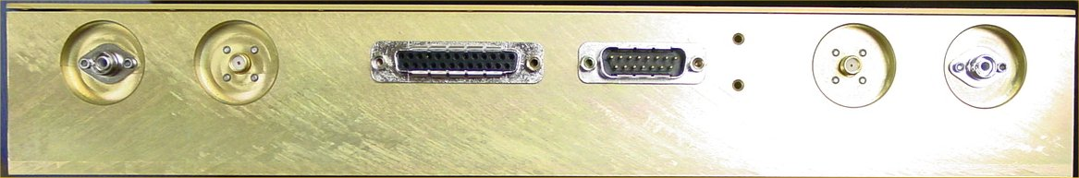
Y
X
D25S
D15P
Figure 1: Annotated picture of the “front-panel” of the PAX box.

D25S – powers LNA’s from PAX control board.
D15P – powers PAX from rim power box (+ TEC thermistors)

*Pin-out D25S |  |  | *Pin-out D15P
1 | GND |  | 1 | GND
2 | Vdrain Y |  | 2 | +6
3 | GND |  | 3 | GND
4 | Future |  | 4 | -6
5 | Future |  | 5 | GND
6 | Vgate X |  | 6 | NC
7 | GND |  | 7 | TEC therm1
8 | GND |  | 8 | TEC therm2
9 | Vdrain X |  | 9 | +6
10 | NC |  | 10 | GND
11 | Future |  | 11 | -6
12 | NC |  | 12 | GND
13 | NC |  | 13 | +sense
14 | Vminus Y |  | 14 | -sense
15 | GND |  | 15 | NC
16 | GND
17 | Vgate Y
18 | Future
19 | Future
20 | GND
21 | Vminus X
22 | NC
23 | Future
24 | NC
25 | NC

*Colored pairs above denote twisted pairs.

